Docker Task -2
Task Description:
Create a dockerfile, docker-compose file which when executed must display your basic details in the website.
=============================================================
Step -1 Create a Docker file: -
- Create an EC2 instance
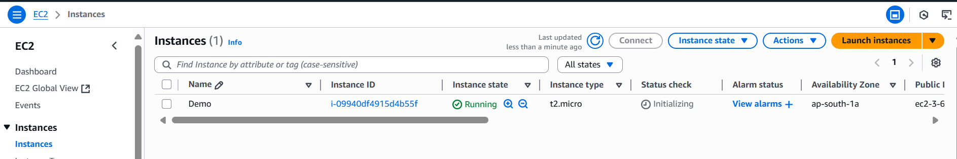

- Once created EC2, Click Connect and update latest libraries using the command is,
apt-get update
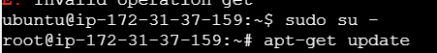

- Install docker in EC2 using this command is,
apt install docker.io -y

- Once installed docker successfully then check the version of docker using this command is,
docker --version

- Go to the below local path
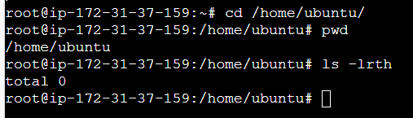

- Create one new folder [ Folder Name is DockerFile] and create Dockerfile without any file extension (Basic Instructions to create docker image) inside the DockerFile Folder
- Command to create empty folder is
mkdir <Folder Name>
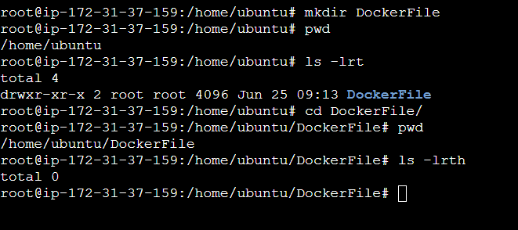

- Command to create empty file is
touch filename
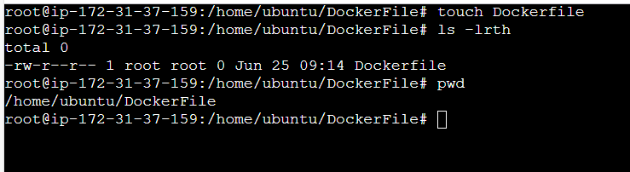

- Add the below instructions inside Dockerfile to create docker image
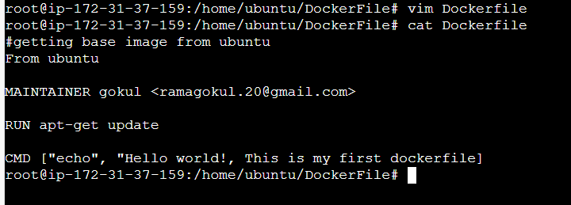
Instructions inside docker file is,
#getting base image from ubuntu
From ubuntu

MAINTAINER gokul ramagokul.20@gmail.com

RUN apt-get update

CMD [“Message is”]

Here,
#getting base image from ubuntu
From ubuntu
In the above line we are getting the ubuntu image from docker hub to local EC2
MAINTAINER gokul ramagokul.20@gmail.com – This line refers maintainer username and email id
RUN apt-get update – This line refers update the latest packages for ubuntu
CMD [“Message is”] – This line refers command to execute given message.

- Below command is to see the list of available docker images in EC2
docker images
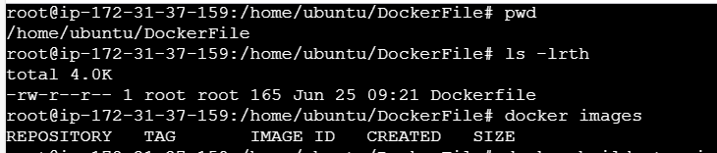

- Below command is to build docker image from docker hub and rename the image with proper name and give tag to the image
Docker build -t <image name>:<Tag Name> .
Here end of the command we need to mention “.” (dot). Dot refers current working directory
Note – docker build command is to build docker image based on the Dockerfile we
created already.
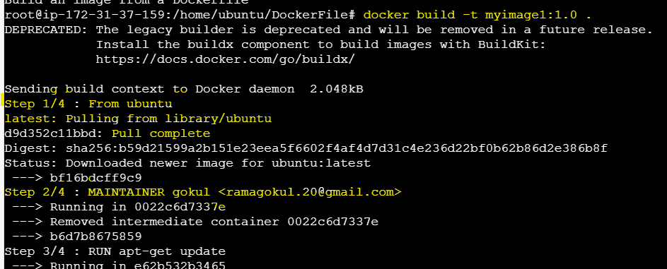
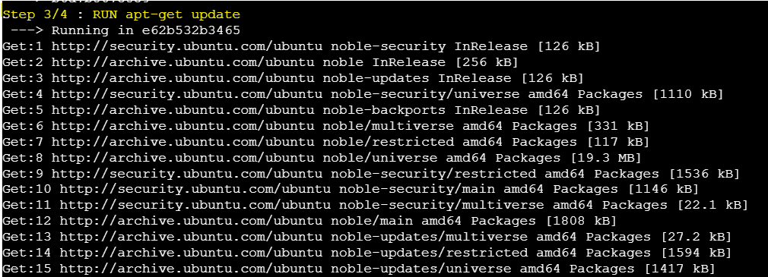
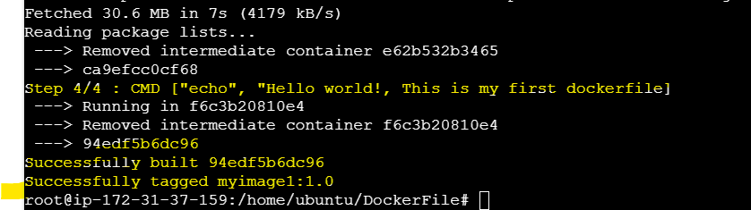

- Below command is to see the available docker images in EC2
docker images
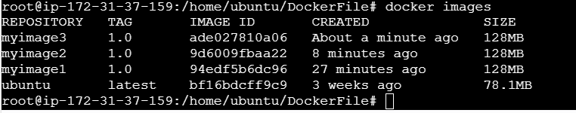

- To run docker image using below command is
docker run < image name >
(or)
docker run <image id>

Step -2 Create Docker Compose File: -
2.1 Install Docker-Compose: -
- First check docker- compose is available or not using this below command,
docker-compose --version
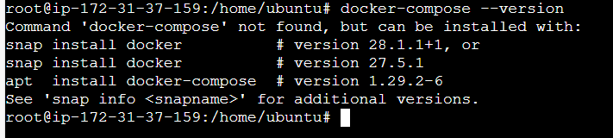

- If the docker-compose is not available run the below command to install it
curl -SL https://github.com/docker/compose/releases/download/v2.37.2/docker-compose-linux-x86_64 -o /usr/local/bin/docker-compose
chmod +x /usr/local/bin/docker-compose
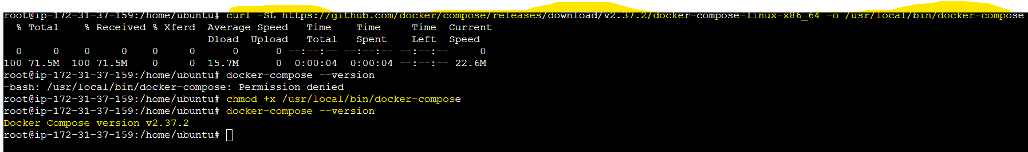

- Once executed the above commands then check the docker version using the below command,
docker-compose –version

2.2 Create docker compose file: -

- Create empty directory in any path and directory name is DockerCompose,
mkdir <directory name>

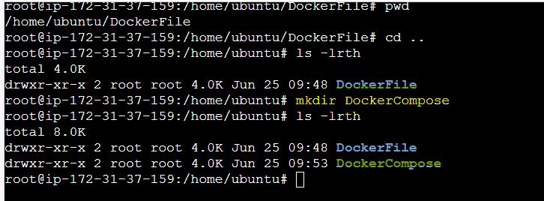
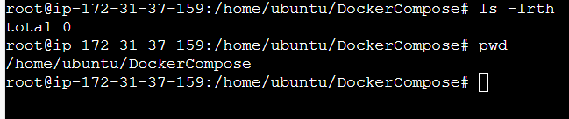

- Inside the above created directory, create docker-compose.yml file
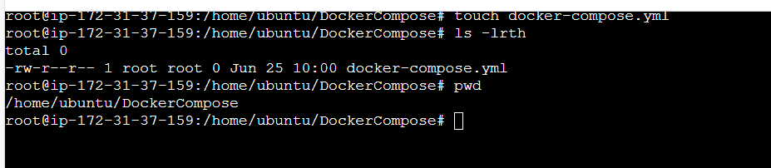

- Add the below highlighted script inside docker-compose.yml file
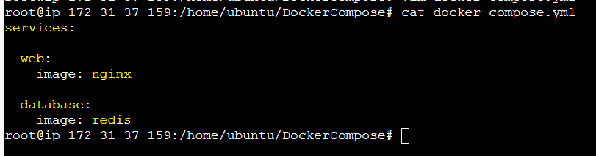

- Below command is to check the validity of the file,
Command is docker-compose config
Note: -
If the file is valid then the script executed without any error otherwise the config command is not executing like below and throw an error
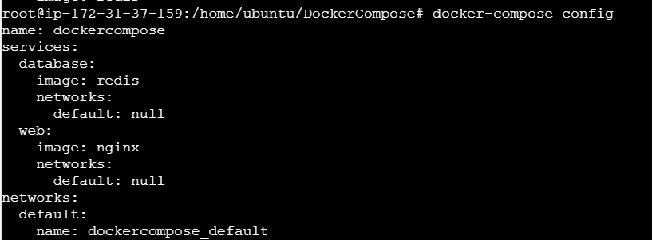

- Run docker-compose.yml file to pull the docker image from docker hub using the below command,
Docker-compose up -d
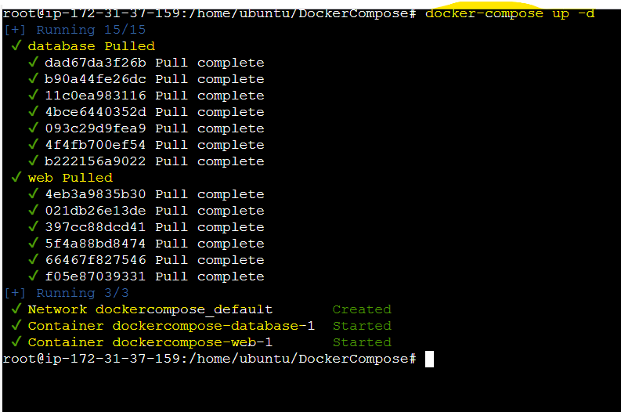

- Now check the docker images available in EC2 using the below command,
docker images
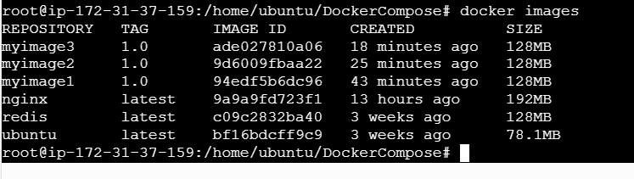

- Now add the ports in docker-compose.yml file to spin up the container,
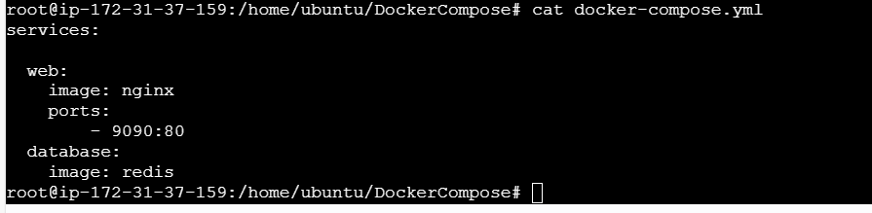

- Below command is to check the validity of the file,
Command is docker-compose config
Note: -
If the file is valid then the script executed without any error otherwise the config command is not executing like below and throw an error
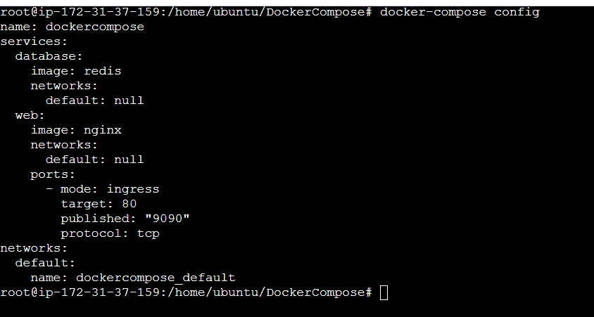

- Run docker-compose.yml file to pull the docker image from docker hub using the below command,
Docker-compose up -d
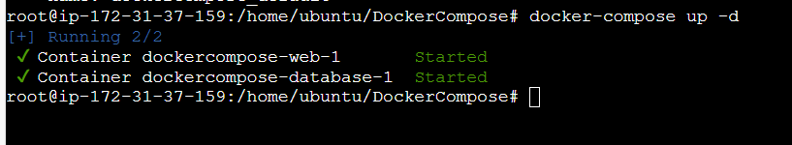

- Now check the docker images available in EC2 using the below command,
docker images
(or)
docker-compose ps

- Below command is to check the available container and its details,
docker ps

- In EC2 -> Security group -> Add new port: 9090
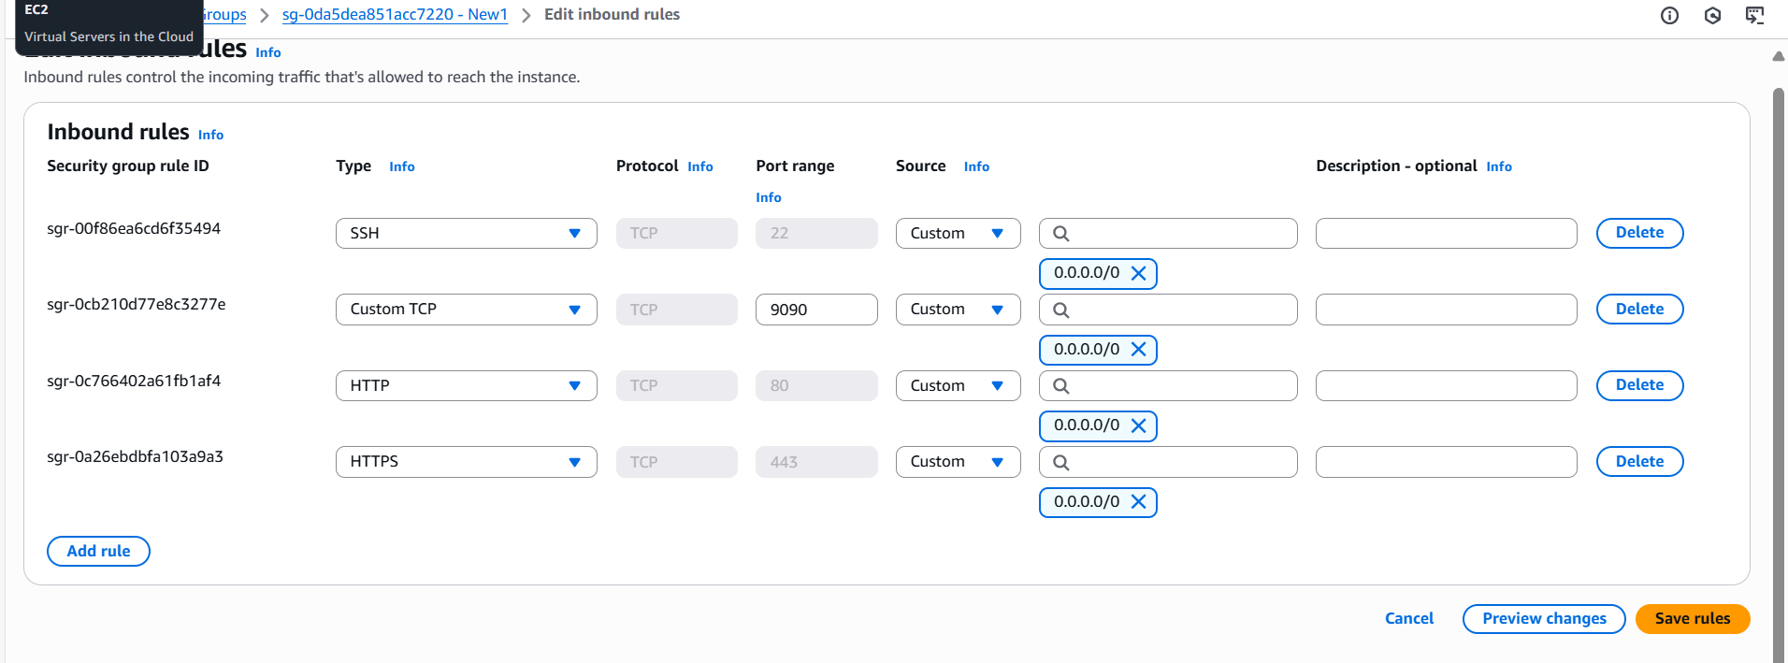

- Once added the ports in security group, reboot the instance or stop and start the container to reflect the above security group changes.
- Reboot the instance Go to EC2 -> Instance state -> Reboot instance
- Stop the Docker Container docker-compose down
- Start the Docker Container docker-compose up

- Test the local host connectivity for port 9090 to get the webserver using the below command,
curl localhost:9090
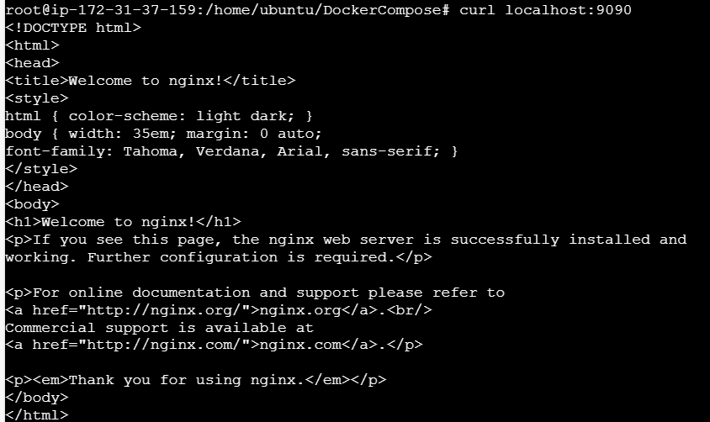

- Hit the public URL with respective port (9090 for nginx) to get nginx webpage
